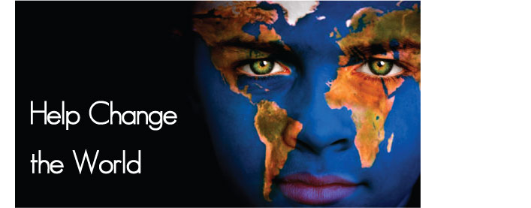

2016 Global Humanitarian Summit
March 18-20, 2016
Atlanta, GA, USA

Date: _________________

American Embassy ________________________________

Address (City, Region, Country): ____________________________
____________________________
____________________________

Dear Sir or Madam,

The Global Humanitarian Summit is pleased to offer __(Full Name)__ a place in our annual conference in Atlanta, Georgia, USA, March 18-20, 2016. The summit is a conference that is entirely non-profit and voluntary where speakers, exhibitors, and sponsors who wish to attend come at their own expense.

We believe that (he/she) will be an excellent contributor to this great event and urge you to grant (him/her) a visa so that (he/she) can attend.

The Global Humanitarian Summit is a cross-disciplinary conference to connect and inspire humanitarians and globally represented NGOs from all over the world to foster and facilitate open dialogue aimed at promoting a synthesis of ideas and active humanitarianism across diverse disciplines and professions.

I hope that you will grant __(Full Name)__ with a visa to attend the Global Humanitarian Summit. We believe that (he/she) and other participants will not only benefit greatly from (his/her) participation, but will inspire others to become humanitarians and to create new partnerships to improve humanitarian efforts.

Please let me know if there is any other information I can provide you with.

Sincerely,

Debbie Ellison
Co-Chair, 2016 Global Humanitarian Summit
Debbie@GlobalHumanitarianSummit.org

