2016 GLOBAL HUMANITARIAN SUMMIT
5th Annual Free Festival
Speakers, Exhibitors, Workshops, Panels,
Entertainment, Youth Summit

www.GlobalHumanitarianSummit.org
info@GlobalHumanitarianSummit.org

March 18-20, 2016
Unity North Atlanta Church
4255 Sandy Plains Road, Marietta, GA
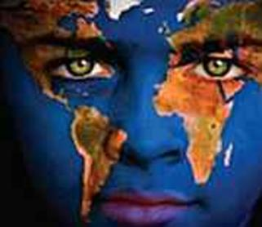

THE GLOBAL HUMANITARIAN SUMMIT is a humanitarian movement and gathering for humanitarians to learn, network, share, connect, and inspire. From all over the world, extraordinary human beings come together to share their humanitarian experiences, expertise, and visions to make the world a better place.

Vision:
To create a world in which every person on the planet enjoys a life that is peaceful, healthy, joyful, and safe, with adequate food, shelter, clean water, and education. We want the human species to deserve the title of "Humanity!"

www.GlobalHumanitarianSummit.org
For more information and/or to volunteer, speak, or exhibit: info@GlobalHumanitarianSummit.org

